Winston the poodle

by Bianca V. Perich

Winston is a miniature poodle and he is 1 year old. Winston was born on January 1, 2022. His coat is black and has so much fur. He even loves sniffing so much. He sniffs so loudly that you can hear him from another room. Winston is hyperactive and eats his food fast. Because he is such a small dog, he is easy to pick up. Winston is picky and chooses who to sit with. Since Winston is so fluffy, when he gets haircuts it takes a couple of weeks for his fur to grow back. Winston can jump very high and run very fast. He also has very cute eyes! I love my Winston very much!

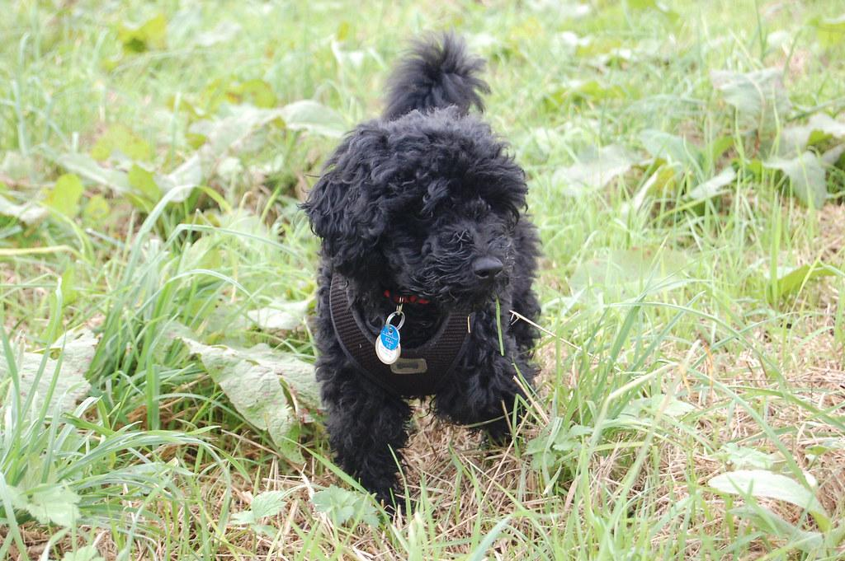

**Picture of what a black miniature poodle looks like.**